

**CSE370**

**Database Systems**

**Spring-24**

**Lab Assignment - 3**

**Name: Faiaz Abrar Zaman Pronoy**

**Student ID: 22301061**

**Section: 13**

**TASK_01**

SELECT c.customer_name, l.loan_number FROM customer c, loan l, borrower b

WHERE c.customer_id = b.customer_id AND l.loan_number = b.loan_number AND

branch_name = 'Downtown';

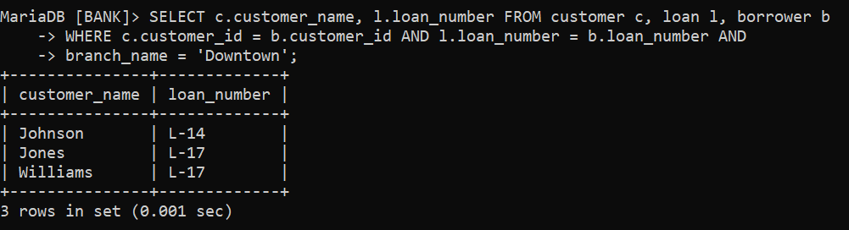

**TASK_02**

SELECT c1.customer_name AS Customer1, c2.customer_name AS Customer2,

c1.customer_city AS City

FROM customer c1, customer c2

WHERE c1.customer_city = c2.customer_city AND c1.customer_id < c2.customer_id;

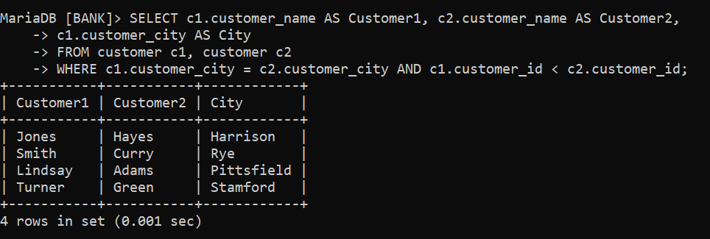

**TASK_03**

SELECT a.branch_name AS Branch_name,

SUM(a.balance * (4/100)) AS Total_Interest

FROM account a

GROUP BY Branch_Name;

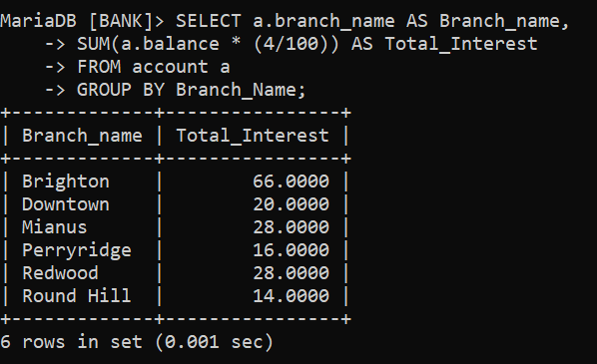

**TASK_04**

SELECT c.customer_city, d.account_number, a.balance AS highest_balance FROM customer c, depositor d, account a

WHERE c.customer_id = d.customer_id AND d.account_number = a.account_number AND

(c.customer_city, a.balance) IN (SELECT c2.customer_city, MAX(a2.balance) FROM customer c2,

depositor d2, account a2 WHERE c2.customer_id = d2.customer_id AND d2.account_number =

a2.account_number AND c2.customer_city = c.customer_city) GROUP BY c.customer_city;

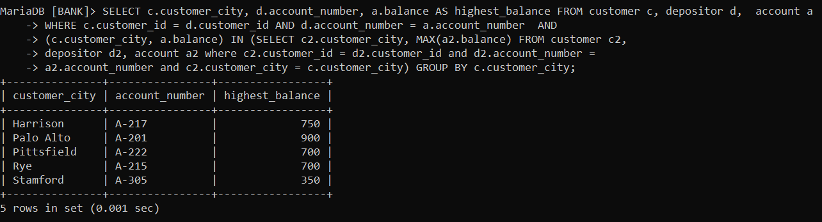

**TASK_05**

SELECT l.loan_number, l.amount, c.customer_name FROM customer c, loan l, borrower b

WHERE c.customer_id = b.customer_id AND b.loan_number = l.loan_number

ORDER BY l.amount DESC, l.loan_number DESC

LIMIT 5;

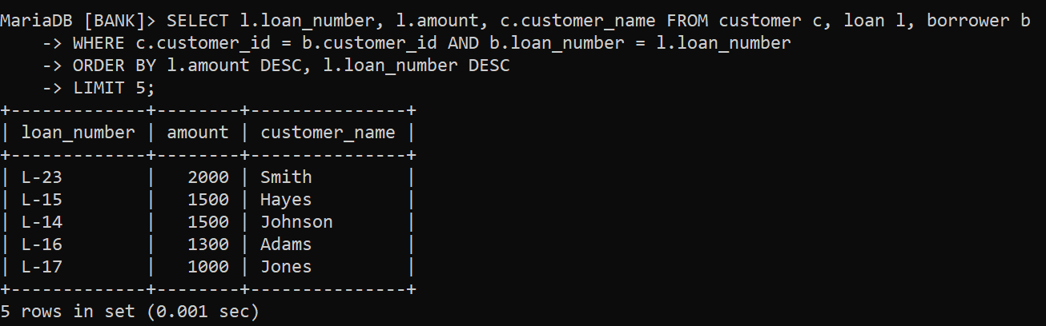

**TASK_06**

SELECT DISTINCT c.customer_name FROM customer c, depositor d, account a,

borrower b, loan l, branch br

WHERE c.customer_id = d.customer_id AND d.account_number = a.account_number

AND c.customer_id = b.customer_ID AND b.loan_number = l.loan_number AND

l.branch_name = 'Perryridge';

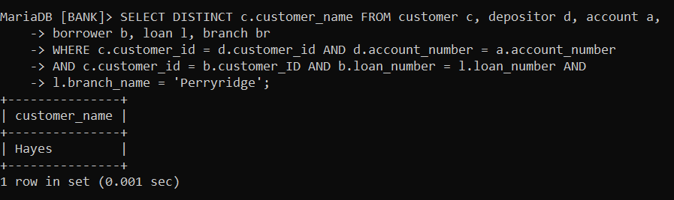

**TASK_07**

SELECT c.customer_name, SUM(l.amount) as total_loan

FROM customer c, loan l, borrower b

WHERE c.customer_id = b.customer_id AND b.loan_number = l.loan_number

GROUP BY c.customer_name

HAVING COUNT(l.loan_number) >= 2;

